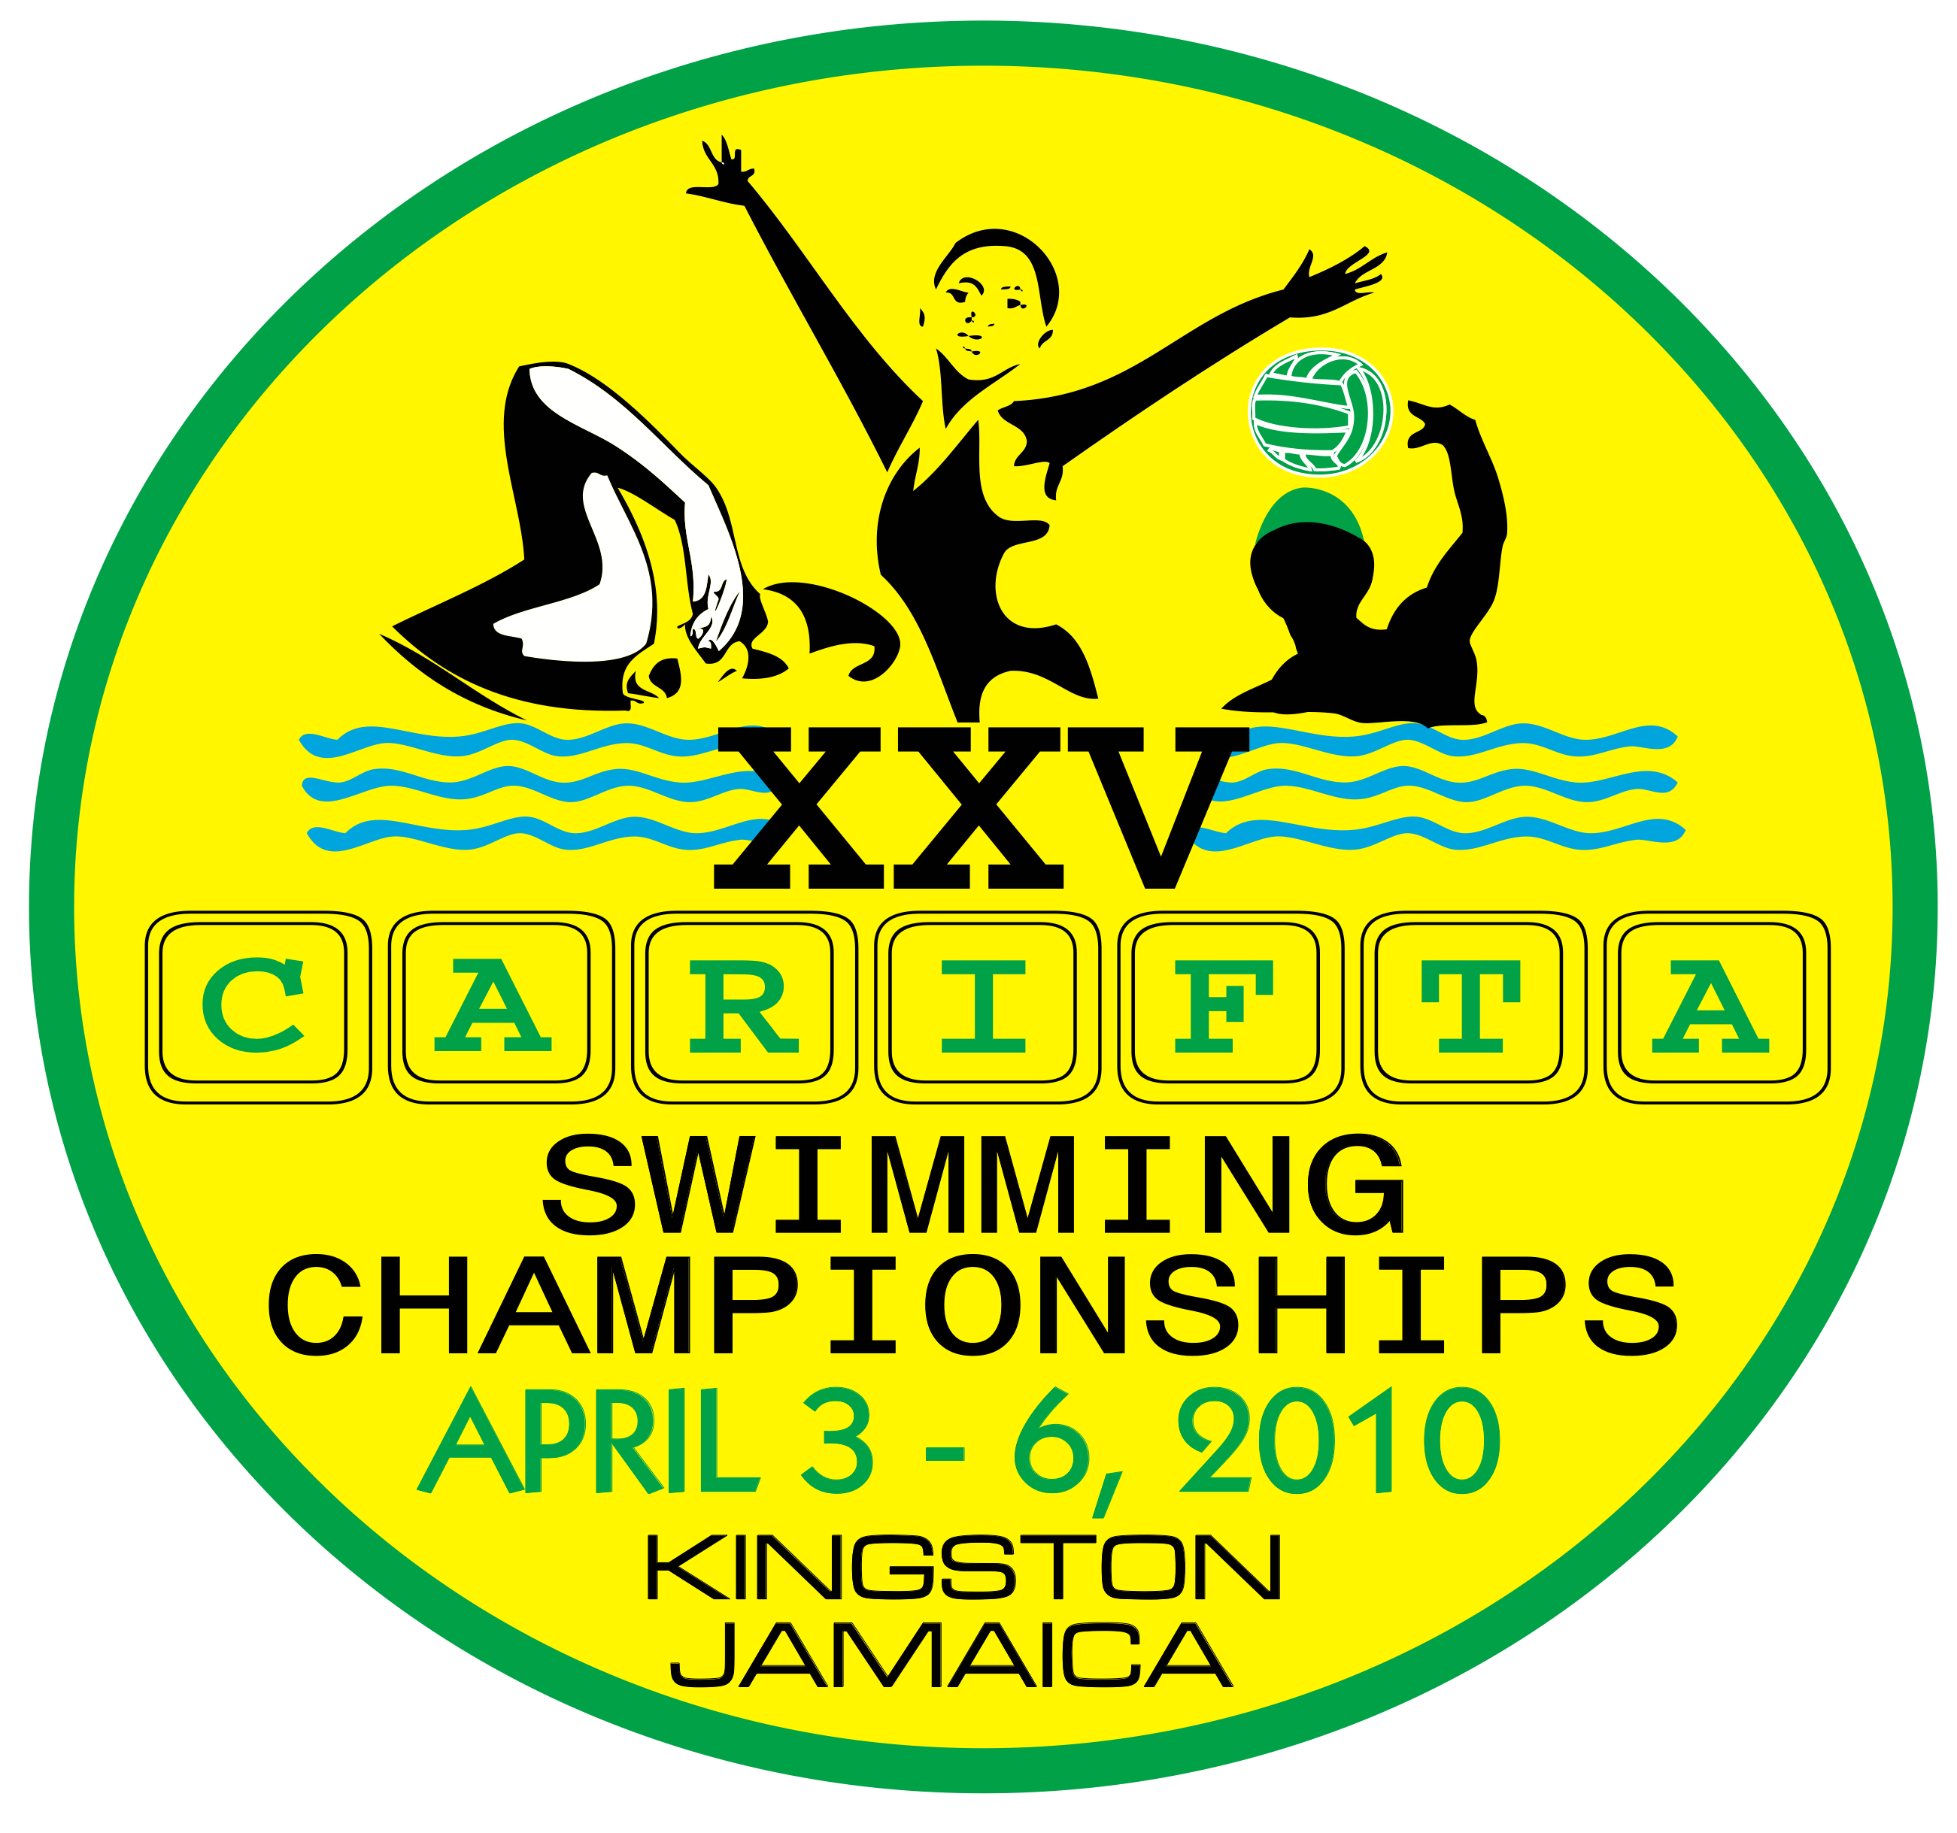

FINA Development Clinic

For

Water Polo Referees

April 2-6, 2010

Kingston, Jamaica

FINA Development Program in association with the
Amateur Swimming Association of Jamaica (ASAJ)

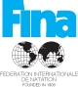

You are cordially invited!!!

Clinic participants will have the opportunity to officiate the CARIFTA Water Polo Competition
Instructor: Mr. Mark Koganov – Mark is a FINA Referee who has most recently had the honor of being the Referee in the Championship Game at two of the last three European Championships and the Championship Game at the 2009 World Championships in Rome.
Invited Federations: All FINA Member Federations (participants must be recomended by their Federation).

Dates: Friday, April 2 - Start of Clinic 12:00 noon
Saturday, April 3 - Clinic and CARIFTA Water Polo Competition
Sunday, April 4 - Clinic and CARIFTA Water Polo Competition
Monday, April 5 - Clinic and CARIFTA Water Polo Competition
Tuesday, April 6 - Clinic and CARIFTA Water Polo. Clinic will end at 4:00 PM

Number of Participants: Thirty (30) on a first come first serve basis.

Language: English

Registration fee: MUST BE PAID BEFORE ARRIVAL

$170 per person, per day (single occupancy)
$105 per person, per day (double occupancy)
Triple and Quad rates are available upon request

NB: THE CARIFTA RATES APPLY TO THOSE PERSONS WHO ARE INCLUDED IN THE OFFICIAL DELEGATION OF A PARTICIPATING COUNTRY.

The registration fee includes:
- Accommodation;
- Meals - breakfast and dinner;
- Transportation from and to airport;
- Transportation between hotel and clinic venues;
- Clinic and material.

Accommodation: Knutsford Court Hotel http://www.knutsfordcourt.com/

Address: The Amateur Swimming Association of Jamaica
National Stadium Pool, Kingston
P.O. Box 15, Kingston 10
Jamaica
Tel: (876)920-6230 / 920-6229
Fax: (876) 920-6129
Email: asaj@cwjamaica.com
Website: www.swimjamaica.com

WATER POLO REFEREES CLINIC
REGISTRATION FORM

This registration entry form must be returned to the Amateur Swimming Association of Jamaica, Organizing Committee, no later than March 1st, 2010.

(Please type or print):

Name of Federation: ____________________________________________________

Country: ______________________________________________________________

Contact Person: ________________________________________________________

Phone No.: _________________________ Fax No: ____________________________

Email Address: _________________________________________________________

Name of clinic participants:

Participant 1: ____________________________________________________

Participant 2: ____________________________________________________

Accommodation type requested: Single______Double______

Date:___________________2010

Stamp and Signature of President or Secretary of Federation: _______________________________

Registrations fees should be wire transferred to the following account (please advise us by email that the funds have been transferred):

The National Commercial Bank Jamaica Limited
1-7, Knutsford Boulevard,
Kingston 5
Jamaica
Swift Number JNCBJMKX
For Credit to Account No. 354249677 in the name of CARIFTA Aquatics Limited

